BASIC LINUX COMMANDS:

**date** - command is used to display the system date and time



**cal** - command displays the current month's formatted calendar on our terminal screen

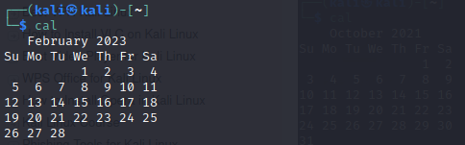

**cd -** command is also called **chdir** (Change Directory). We used this command to **change** or **switch** the current working directory.

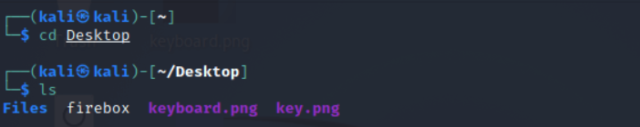

**cp -**  command is used to **copy** files or a group of files or directories that create an exact image of a file on a disk with a different file name.

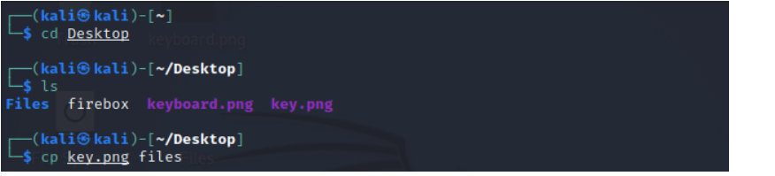

**whoami**  - command is used to print the effective **user ID** whereas the **who** command prints information regarding users who are presently logged in

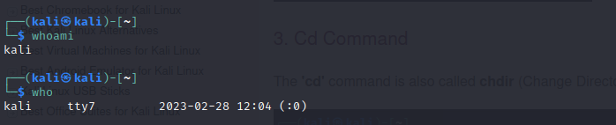

**ls** - command lists the directory contents of files and directories

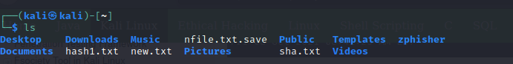

**ls -al**

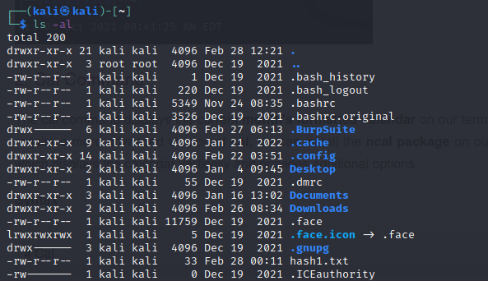

**cat**  - (concatenate) command is used to permitting us to create single or many files, concatenate files and redirect, view contain of file output in terminal or files

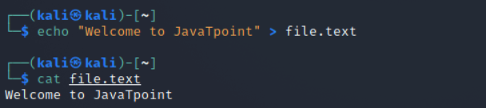**rm** - command is used to **delete files**

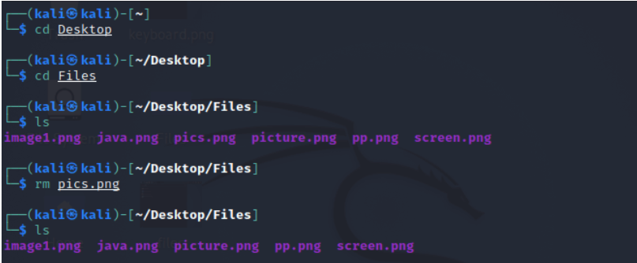

**mkdir – command used to create the directory**

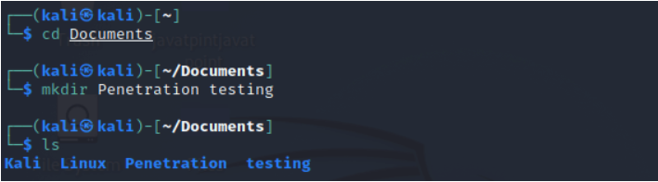

**mv**  - command, we can **move** files and directories on our file system.

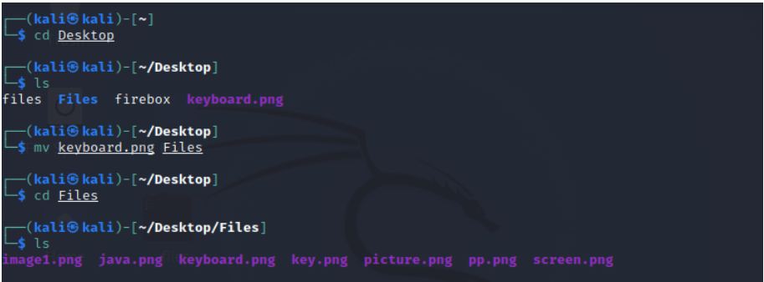

**uname**  - command displays the **current system's information.** We can view system information about our Linux environment with the uname command in Linux. With the **uname -a command,** we can learn more about our system, including **Kernel Name, Node Name, Kernel Release, Kernel Version, Hardware Platform, Processor,** and **Operating System.**

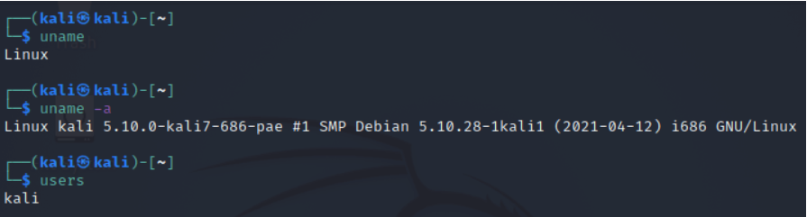

**uptime**  - command displays the amount of time the system has been running.

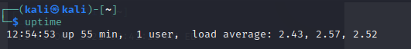

**users**  - command is used to display the **login names** of users logged in on the system.



**less**  - command is used to view files instead of opening the file. The less command is a more powerful variant of the **"more"** command which is used to show information one page at a time to the terminal. Ex: # less /etc/passwd

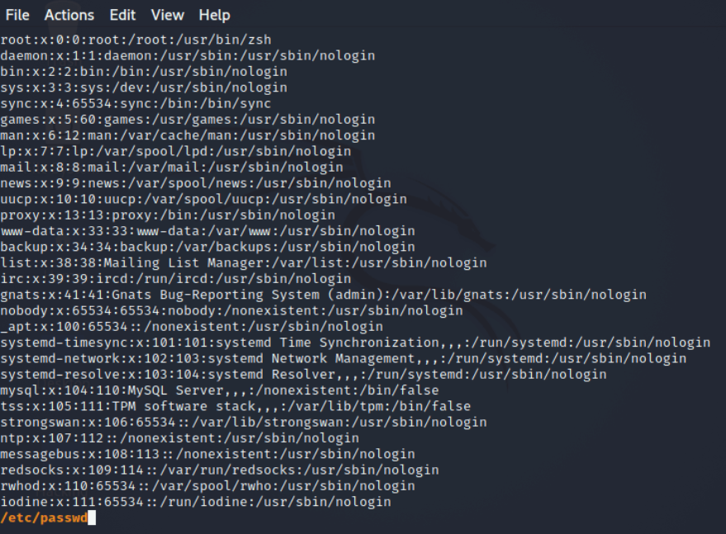

**free**  - command provides us the useful information about the **amount of RAM** available on a Linux machine. It also displays the entire amount of **physical memory** used and available space, as well as **swap memory** with **kernel buffers.**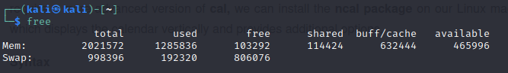

**more -** command permits us to show output in the terminal one page at a time. This is particularly beneficial when using a command that requires a lot of scrolling

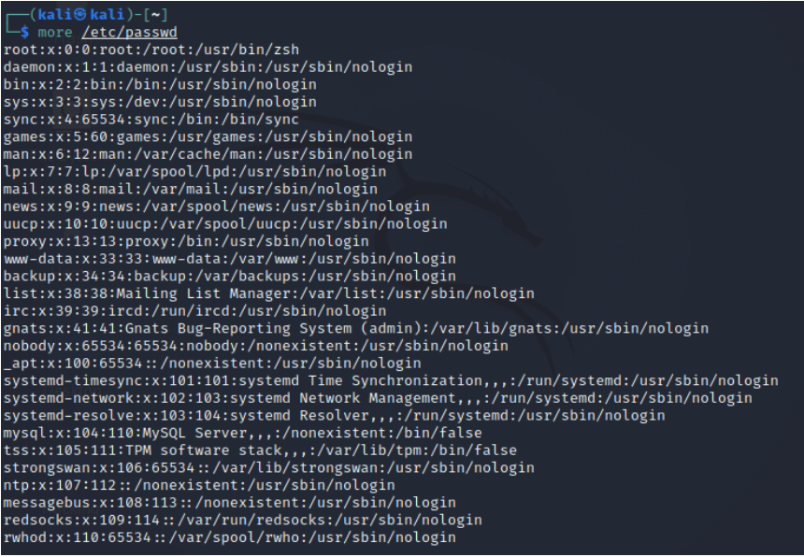

**sort**  -command, we can sort the content of the text file, line by line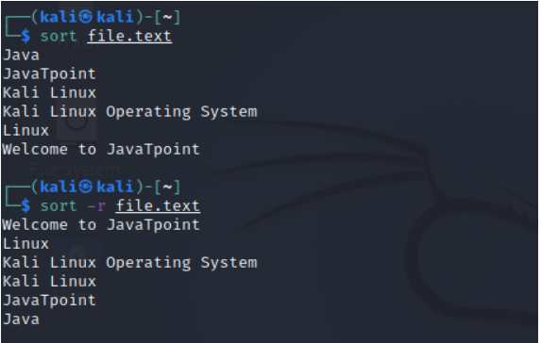

**history** - command print the **current user's bash history**

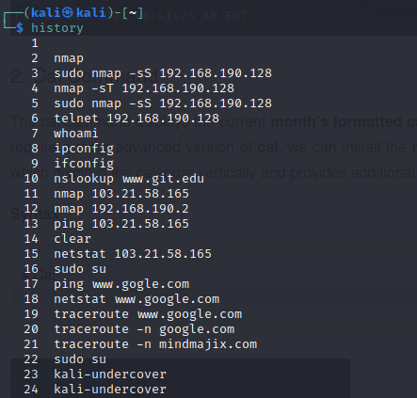

**pwd**  – command is used to **print working directory.**

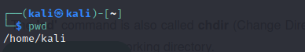

**man -**It displays the user manual for all commands in Kali Linux. It includes Bash command and detailed synopsis with a short description.

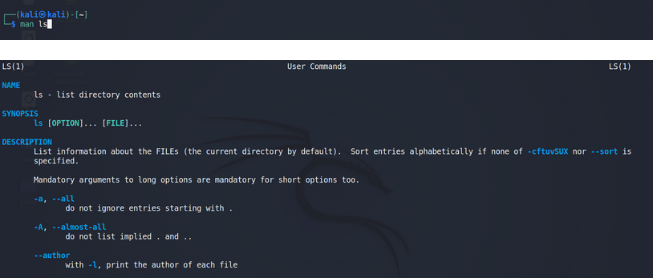

### ****echo** –** This command displays any text as arguments. It is used for debugging shell programs.

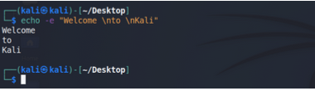

### ****wget**** - This command downloads applications and web pages directly from the web.

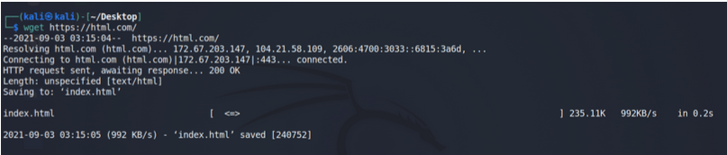

### ****tree -****This command shows the list of contents from a director in the tree fashion

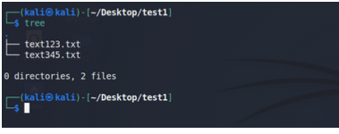

### ****grep -**** This command searches files and prints lines that match patterns.

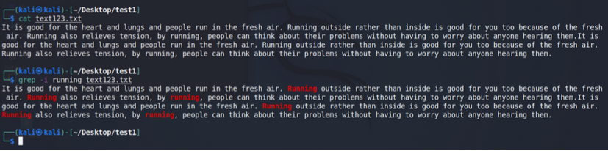

### ****wc -**** wc stands for word count. It shows the number of lines, words, characters, and bytes.

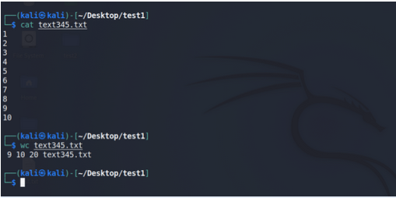

**unzip -** Command used to extract the files from zip file



## **du** - The du command is used to display the amount of disk space used by files and directories.

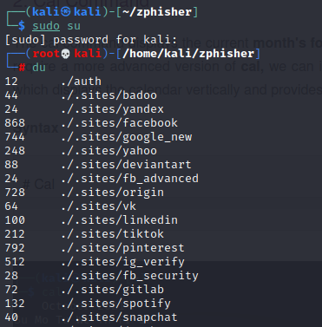

## adduser -

Adduser command is used to add a new user. You can create multiple users by using adduser command.

## **passwd** - command To change password

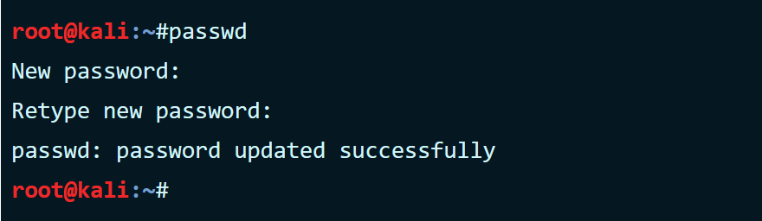

**macchanger -** macchanger changes your mac address, essentially changing your identity. It helps with protecting your anonymity on the internet, making your IP untraceable.

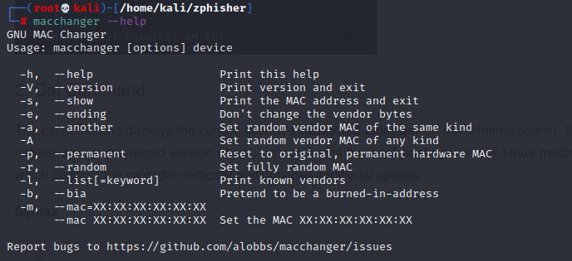

**ifconfig -** ifconfig <=> interface configuration. Used to detect the IP address

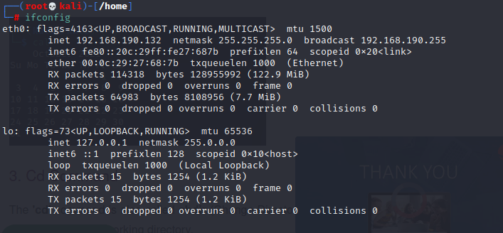

**grep [options] pattern [files]**

command used to search the pattern

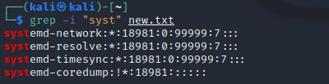

**ping** – command used to troubleshoot devices present in the network

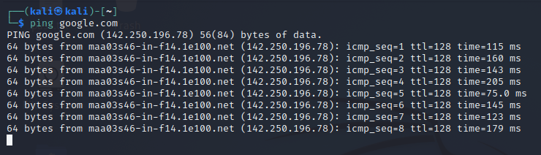

**nslookup** – command used to find the IP of url

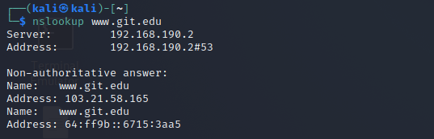

**durb** – command used to find the directories of the target

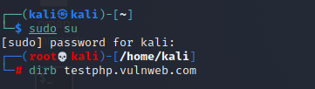

**theHarvester** – command used to find the official email ids

**traceroute** –It provides the names and identifies every device on the path.

1. It follows the route to the destination
2. It determines where the network latency comes from and reports it.

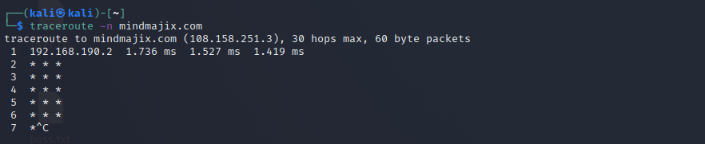

**ip** – This command gives the details of all networks like ifconfig.This command can also be used to get the details of a specific interface.

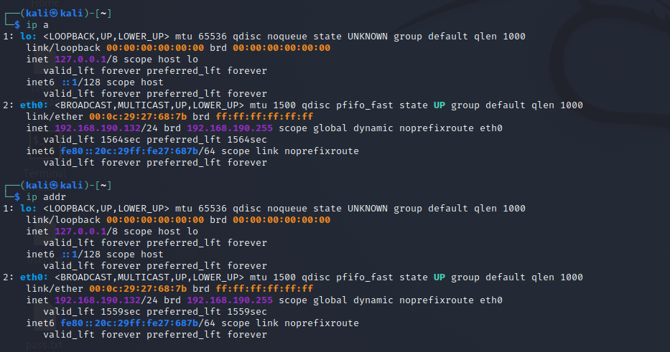

**tracepath** - Linux tracepath is similar to traceroute command. It is used to detect network delays. However, it doesn't require root privileges.

Syntax : tracepath mindmajix.com

**netstat** - Linux netstat command refers to the network statistics.

It provides statistical figures about different interfaces which include open sockets, routing tables, and connection information.

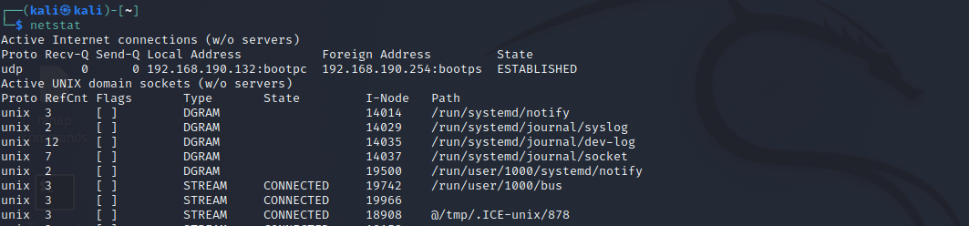

This displays the programs associated with the open socket.

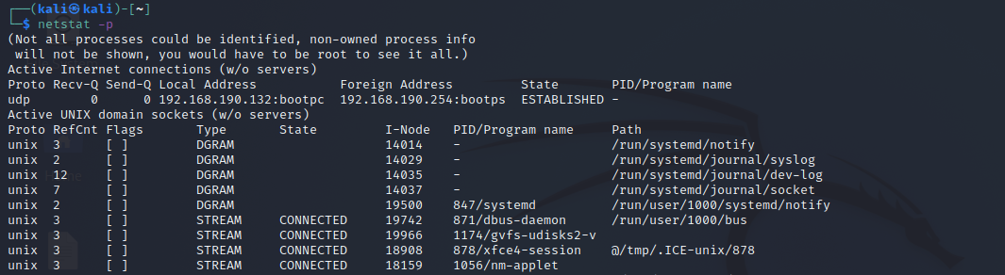

This gives detailed statistics of all the ports.

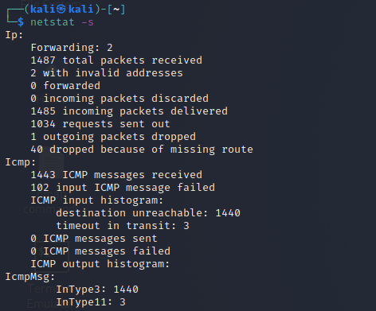

information related to the routing table.

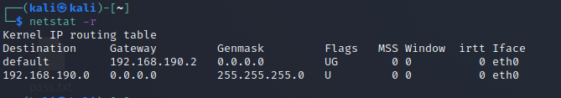

**ss** –

This command gives information about all TCP, UDP, and UNIX socket connections.

You can use -t, -u, -x in the command respectively to show TCP/UDP or UNIX sockets. You can combine each of these with "a" to show the connected and listening sockets.

**Syntax:**

ss -ta

ss -ua

ss -xa

If you want to see only the listening sockets of TCP/UDP or UNIX sockets, combine it with "l"

**Syntax:**

ss -lt

ss -lu

ss -lx

* To get a list of all the established sockets of TCP for IPV4,

#### Command:

$ ss -t4 state established

* To get a list of all closed TCP sockets,

#### Command:

$ ss -t4 state closed

* To get a list of all connected ports for a specific IP address:

**dig** -Linux dig command stands for Domain Information Groper. This command is used in DNS lookup to query the DNS name server. It is also used to troubleshoot DNS related issues.

It is mainly used to verify DNS mappings, MX Records, host addresses, and all other DNS records for a better understanding of the DNS topography.

#### Command:

$ dig google.com MX

* To get all types of records at once, use the keyword ANY ass below:

#### Command:

$ dig google.com ANY

**route**-

Linux route command displays and manipulates the routing table existing for your system.A router is basically used to find the best way to send the packets across to a destination

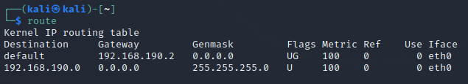

**host** –

Linux host command displays the domain name for a given IP address and IP address for a given hostname. It is also used to fetch DNS lookup for DNS related query.

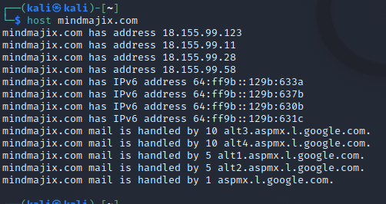

**arp**-

Linux arp command stands for Address Resolution Protocol. It is used to view and add content to the kernel's ARP table.

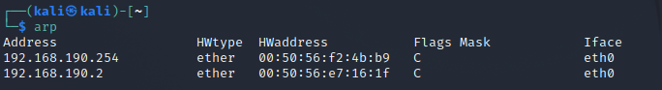

**iwconfig** –

Linux iwconfig is used to configure the wireless network interface. It is used to set and view the basic WI-FI details like SSID and encryption. To know more about this command, refer to the man page.

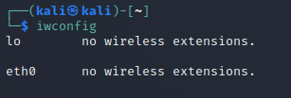

**hostname**-

Linux hostname is the simple command used to view and set the hostname of a system.

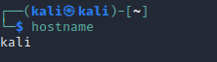

**curl or wget –**

Linux curl and wget commands are used in downloading files from the internet through CLI. The curl command has to be used with the option "O" to fetch the file, while the wget command is used directly.

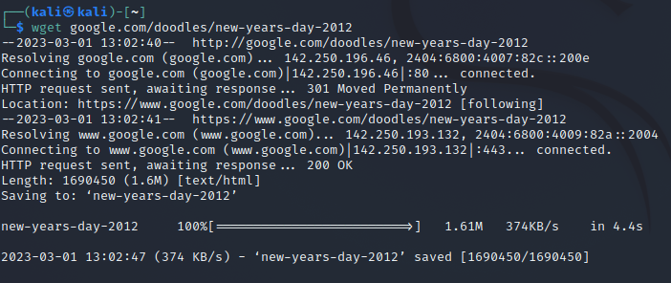

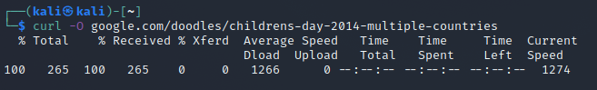

**whois** - Linux whois command is used to fetch all the information related to a website. You can get all the information about a website including the registration and the owner information.

